# **Abstract**

We aim to design a controller for a non-linear system in order to meet the proposed design requirements, while ensuring stability. Now to solve this problem, we will be using classic as well as modern approaches to meet the design requirements. We will also verify the effectiveness of designed controller on MATLAB and show the results. We will set the constraints ourselves for the ease of demonstration.

# **Introduction**

The system at hand is a ‘**Rotary Inverted Pendulum**’. We can see from the basic equation below that it is a non-linear system.



Our plant has following specifications:

|  |  |  |  |
| --- | --- | --- | --- |
| Parameter | Symbol | Value | Unit |
| Moment of inertia of arm and pendulum | Jeq | 1.84e-6 | kg-m2 |
| Mass of pendulum | m | 0.0270 | kg |
| Rotating arm length | r | 0.0826 | m |
| Gear ratio | K | 1 | - |
| Moment of inertia of rotor | Jm | 1.80e-4 | kg-m2 |
| Gear box efficiency | g | 1 | - |
| Motor efficiency | m | 0.69 | - |
| Half-length of pendulum | L | 0.0955 | m |
| Gravity acceleration | g | 9.8 | m/s2 |
| Motor torque constant | Kt | 0.0334 | N-m |
| Armature resistance | R | 8.7 | ohms |

We have already derived our transfer function between the angle of pendulum and voltage applied at motor.

We have,

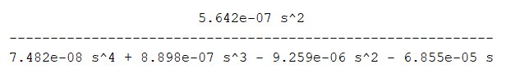

Now the modeling portion is explained and we will explain how to meeting the design requirements.

We will be deciding our design constraints and then we will use **State space** and **Root Locus** approach to meet the design requirements.

# **Design Requirements**

|  |  |
| --- | --- |
| Constraint | Range |
| Percentage Overshoot | ≤20% |
| Rise time | ≤0.2sec |
| Settling Time | ≤0.5sec |
| Steady state error | 0 |